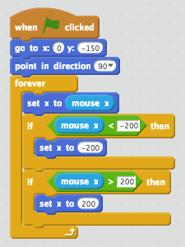**Paddle (Lesson 1)**

**Breakout (intermediate)**

1)Find a sprite paddle. Name it “paddle”.

2)Find a space background.

3)Let’s make the paddle **go to the bottom of screen** and **point left and right**.

4)Add code to have the paddle move where mouse is.

5)Set boundaries for the paddle (-200, 200).

**Ball**

1)**Upload ball sprite** and make it **start in the middle of the screen**. **Set speed variable to 10.**

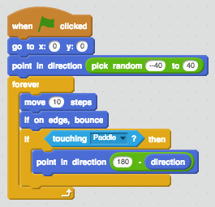2)First make the **ball** **bounce around the screen** **back and forth on a straight line** and **point it in the direction of down** (180).

3)Put **random number (-40,40) in point direction** part.

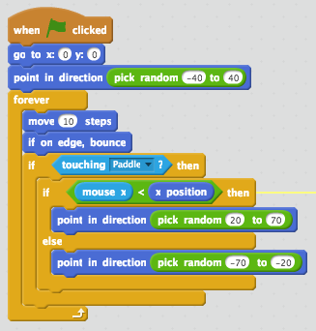4)Then **If the ball hits the paddle** make the **ball bounce off in the correct direction**.

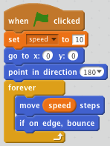

5)Make it so when the ball hits the right side of the paddle it bounces more the right and when the ball hits the left side of the paddle it bounces more to the left. **Replace “point in direction…” with the following code**.

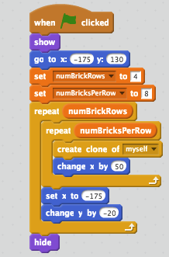**Bricks (Lesson 2**)

1)**Create brick**, then **when flag is clicked** have it **go to x:-175 y:130**.

2)Create 2 variables, numBrickRows = 4 and numBricksPerRow = 8.

3)Then we will have **2 repeat block**s nested together. 1 for rows, other for bricks per row. Inside the nested one put **create clone of myself** and **change x by 50**. On the outside put set **x to -175** and **change y by -20**.

4)The problem now is with the last brick. To eliminated it we need to put **show** in the beginning and **hide** at the end.

**Deleting Bricks (Lesson 3)**

1)**Go back to the Ball** and add this code: If it is touching the brick then **broadcast checkBrick** and **point in this direction**.

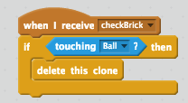2)Go back to Brick and add when I receive checkBrick if touhing Ball delete this clone.

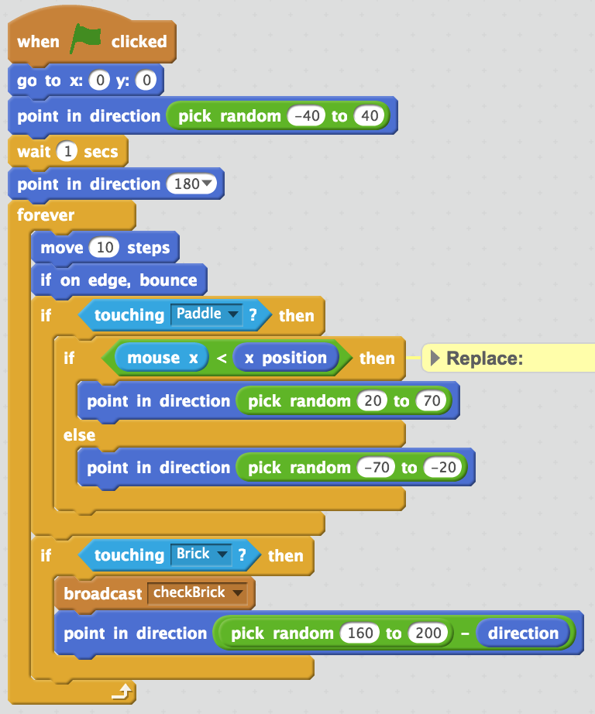

**Points, Game Over and Level Complete (Lesson 4)**

1)Make a Game over sprite.

2)Then go to the ball sprite and add code so when the ball hits the bottom edge the script ends and broadcasts game over.

3)In the Game Over sprite, add code to make it appear in a cool way like this:

4)Make a new variable called “**bricksLeft**”. Go to the brick sprite and set bricks left to 32.

5)Then **add change bricks left by -1** and if the bricks left is zero, **broadcast LEVEL COMPLETE**.

6)Make a Level Complete sprite

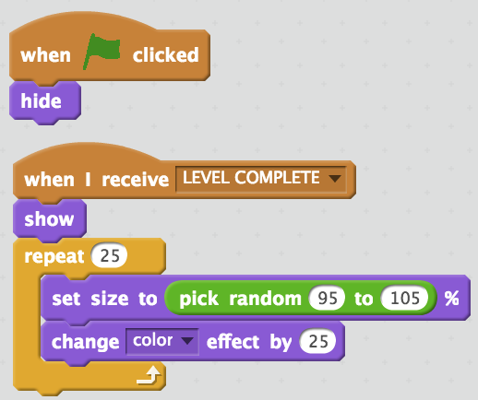7) In the Level Complete sprite, add code to make it appear in a cool way like this:



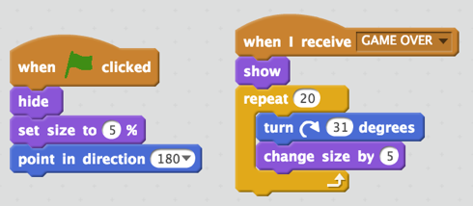

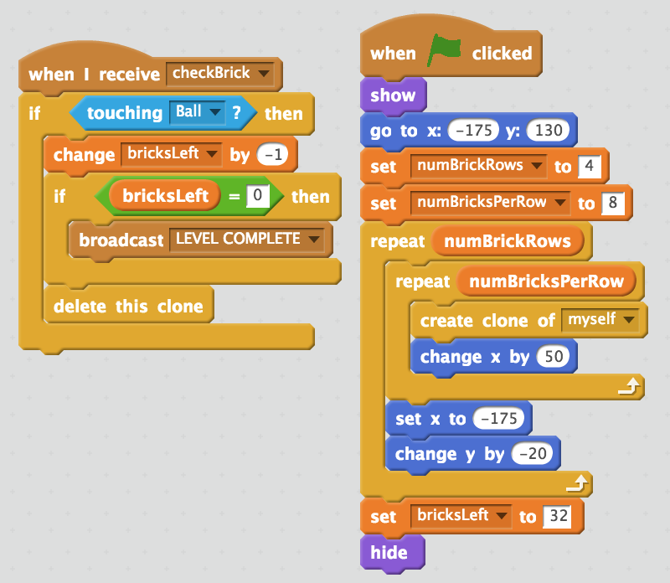

**Extra Challengess**

1)Clone the ball when the space bar is hit.

2)You can add a clone function to do this.

3)Make the speed change faster and slower when up and down arrow keys are pressed.